Step 1:

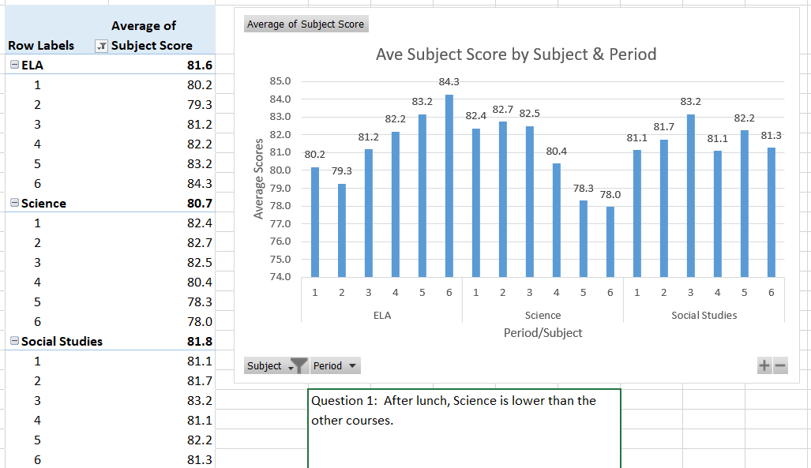

Step 2:

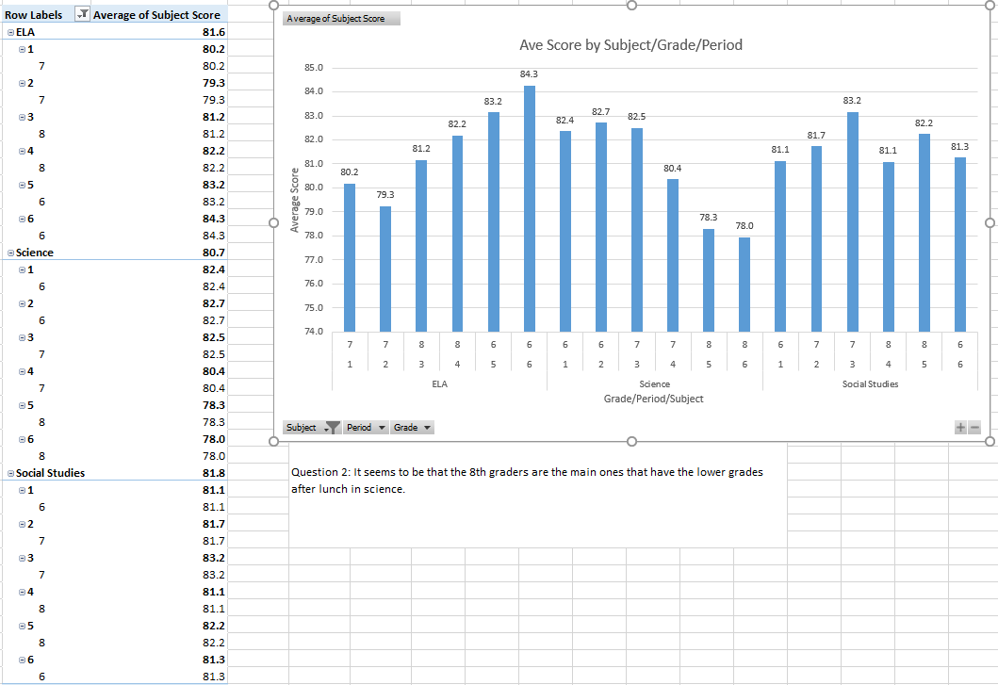

***QUESTION 3***:

Once you receive access to the additional performance data,

* What pivot table(s) would you build to explore a possible relationship between student performance, grade level, subject, and period?
  + It would be nice to see the 8th and 7th grader’s grades in science over their entire time in middle school including 5th grade.
  + Is there any historical data of 8th graders having science in the morning?
  + Could we compare the different teacher scores as well?
* Can your results from Advanced Academic courses be generalized to the entire student population? Why or why not?
  + It is dangerous to generalize information across different grade bands. Middle school students can perform very different between the different grade bands due to the students growing up. It would be nice to see the grades progress though through middle school. A couple of questions to check is if there are new teachers, outside influences, curriculum changes, etc.